FOR IMMEDIATE RELEASE
Team to Embark on Groundbreaking Kayak Expedition Across the Okavango Delta to Highlight Climate Change Impacts
Okavango Delta, Botswana — June/July 2025
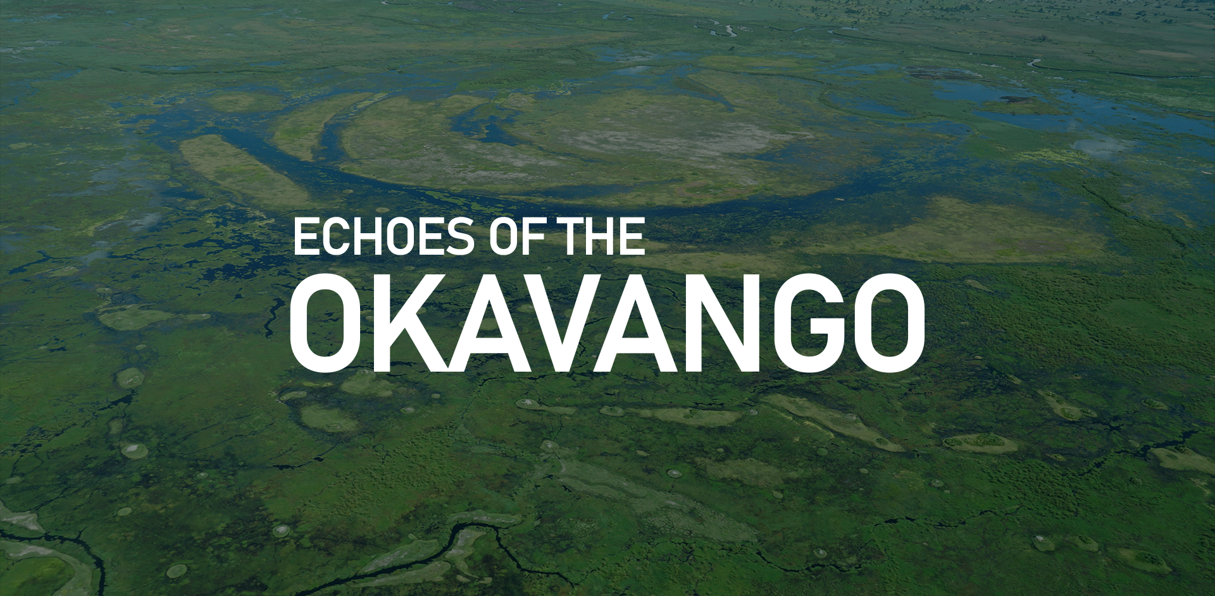The Okavango Delta in full flood, Summer 2024. Photo by Sheila C.
In Summer 2025, a team of explorers will paddle through one of the world’s most remarkable ecosystems, the Okavango Delta, to raise awareness of the urgent impacts of climate change and promote conservation efforts. The 300-kilometer kayak expedition, led by adventurer Jay Frain, will navigate the Delta’s pristine waterways, bringing its unique beauty and ecological challenges to a global audience.
A Mission for Conservation and Storytelling
Dubbed Echoes of the Okavango, the expedition is more than an adventure; it is a mission to inspire action to protect this UNESCO World Heritage Site. The Okavango Delta, often called the "Heart of Southern Africa," spans up to 15,000 square kilometers during peak flooding, hosting a vast array of wildlife including elephants, lions, and endangered species like the African wild dog and the slaty egret. However, its delicate ecosystem faces increasing threats from climate change and human activity.
“This journey is about more than exploration,” says Jay. “It’s about capturing the Okavango’s story—its breathtaking landscapes, resilient wildlife, and the people who depend on it—to inspire a global effort to safeguard its future.”
Through photography, a documentary film, interviews with local communities, and a citizen science project, the team aims to document the Delta’s ecological and cultural significance while highlighting the environmental challenges it faces. Their work will be shared through various platforms, including social media, an expedition journal, and post-expedition workshops and lectures.
An Immersive Journey Into the Delta
The expedition will span approximately two weeks, beginning at the Delta’s northern tip in Sepupa and concluding in Maun. Team members will kayak through a labyrinth of waterways, stopping to interact with local communities and observe wildlife at iconic sites such as Chief’s Island. Each day will combine paddling with fieldwork and creative storytelling projects.
Citizen Science and Collaboration
In collaboration with conservation partners, the team will engage in a citizen science initiative to gather critical environmental data. The findings will contribute to ongoing efforts to study the Delta’s ecosystem and its responses to climate change.
A Call to Action
Echoes of the Okavango invites the global community to follow their journey and support their mission. The expedition’s stories and findings will be shared in real-time through social media (@OkavangoEchoes) and later presented in workshops, educational talks, and a short documentary film.
Supporters can also contribute to the expedition through its Patreon page, helping to amplify the message of conservation and climate action whilst learning all the exclusive information about the planning and execution of the project.
NOT FOR PUBLICATION:
Access Our Media Kit: High-resolution photographs and additional materials are available at
Join the Conversation
For media inquiries, interviews, or to learn more about the expedition, please contact:
Jay Frain
Expedition Leader
Email: jay@okavangoechoes.com
Phone: 07889 791803
Instagram: @Jay.Frain
Visit the expedition’s website at okavangoechoes.com for updates and additional information.

